Year 2 Unit 3
Main subject focus: History

In History our enquiry question is What is nursing, and what famous nurses have lived in Britain?

The children will investigate this question through the following 6 key questions:
- Why is Florence Nightingale remembered today and what did she do in her life?
- Why did Florence go to the Crimea and who influenced her?
- What did Florence do to help the soldiers and did everyone have the same opinion of her?
- What were the most important achievements of Florence’s life?
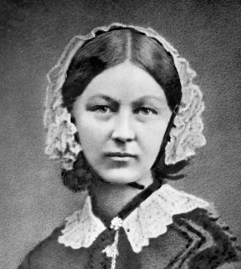
- Why have we learnt so much about Florence and so little about Mary Seacole?
- How should we remember Florence Nightingale and Mary Seacole?

English:  In our English lessons we will be writing a narrative based on the short film ‘My Christmas Star’ by the BBC. In the new year, we will be learning about the life of Grace Darling in preparation to write a biography for one of our famous nurses- Mary Seacole or Florence Nightingale. |  | Maths:  In maths we will be learning to recognise the names and properties of 2D and 3D shapes.  We will then be deepening our understanding of Money.
PE:  Indoor: Gymnastics  Outdoor: Ball Skills – Feet  Football - (Passing, shooting, dribbling, movement)  PE days: Monday & Wednesday afternoons Please tape up or take out earrings and tie long hair back. | RE:  Who is a Muslim and how do they live? (Part 2) |  | Phonics:  Unit 35  Sound /v/ by spellings v ve vv  Unit 36 More spellings of sound /oo/ (moon) ui ou ough u u-e  Unit 37 Sound /j/ by spelling j g ge gg dge
Music:  Unit 3- Rhythm | Computing:  Programming Unit A 1 Moving a Robot  E-Safety: Online reputation |  | PHSE:  Harmful substances and healthy lifestyles

