Year 2 Unit 2
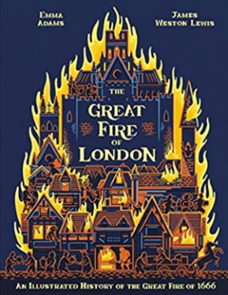
Main subject focus: History
In History our enquiry question is: What was the Great Fire of London and what consequences did it have?
The children will investigate this question through the following 6 key questions:
KQ1: What was it like to live in London 450 years ago?
KQ2: What are the significant dates and events of the Great Fire of London?
KQ3: How did the fire spread and how did people stop it?
KQ4: How do we know about the Great Fire of London?
KQ5: How did the Great Fire of London change the way people built?
KQ6: How did the Great Fire of London change the way people fight fires?
English:  In our English lessons we will be learn how to write our own diary based on our learning about the Great Fire of London and the book The Great Fire Of London - An Illustrated History of the Great Fire of 1666 by Emma Adams. |  | Maths:  In maths we will be deepening our understanding of addition and subtraction of numbers up to 100. We will also be learning to instantly recall doubles and halves of numbers up to 20.
Science: Uses of everyday materials (Continued)

KQ5: Why are some things better than other things for a particular purpose part 1 – knowing what to build their house from to help stop fire burning? -link with Great Fire of London
KQ6: Why are some things better than other things for a particular purpose part 2 – investigating-What would be the best material to make a container to carry water from?
KQ7: How have scientists helped us live safer lives?

PE  Indoor: Dance  Outdoor: Ball skills  PE days: Monday & Wednesday afternoons Please tape up or take out earrings and tie long hair back. | Art  Drawing and painting  Mondrian  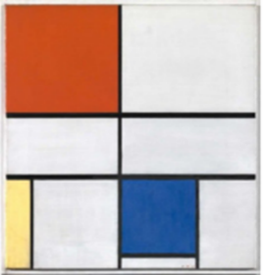 |  | Phonics  Unit 31 Spelling <y> representing /y/ /i/ /ie/ & /ee/  Unit 32 More spellings of sound /oe/ ‐ ou ough  Unit 33 Sound /n/ by spellings n nn gn kn  Unit 34 More spellings of sound /er/ ‐ ar ear our
RE

Why does Christmas matter to Christians (Incarnation)?

Music  Unit 2: voice | Computing  Digital Photography  E-safety  Online relationships |  | PHSE:  Relationships: Family and Friends

