FS Unit 3: Peace & Conflict: Can You Tell Me a Story?
Main subject focus: Understanding of the World (Science & History)
The children will learn
- about different materials, including names​
- which materials are suitable for particular purposes​
- about some of the properties of materials such as if
they are waterproof
- what the first shoes were made of​ and that shoes were an indicator of wealth
- how shoes have changed over time (manufacture/materials)​
- Thomas Crick (from Leicester designed machinery
to make shoes)​
The children will also be exploring nursery rhymes and finding out about how life in the past was different to now.
Communication & Language  Speaking in full sentences to give answers.  Re-telling traditional tales.  Increasing vocabulary linked to new learning including adjectives.  Writing captions & sentences.  Drawing a story map to support the retelling of a story. | Phonics  Continuing to work on skills of segmenting, blending & phoneme manipulation (moving sounds to create new words – eg: changing pot to dot, changing dot to dog)  Sounds-spelling correspondences; d,f,e,v,k,l,r,u,j,w,z,x,y,ff,ll,ss | Maths  Number 11 and 12 (understanding the position of these numbers in the number system and being able to talk about the composition of the numbers. 6+6=12 7+5=12  Positional language  Days of the week  Doubles
Songs and Rhymes  The children will learn lots of nursery rhymes during this topic. We will also teach them playground games such as “What’s the time Mr Wolf?” and Duck, duck, goose. | RE  Why is God important to Christians?  The Nativity Story.  We look forward to performing our school play.  Talking about celebrations and Christmas traditions. | Understanding of the World  Investigating Nursery Rhymes to find out about life in the past.  Floating and sinking – What would happen to the Gingerbread Man if he fell into the river.
Expressive Arts and Design  Looking at the artists Paul Klees and Modrian.  Continuing to talk about colours – lighter, darker, bright, warm, cold.  Plenty of time to explore at the creative table and colour mixing at the painting easel. | Physical Development  Continuing to work on correct tripod pencil grip & strengthening of muscles in hands.  PE – Tuesday and Fridays – please leave your child’s PE bag at school.  Fundamental skills (throwing/catching)  Dance | Understanding of the World continued...  Materials – naming and identifying. Describing properties and suitability for purpose. For example – designing a coat for Little Red Riding Hood. Think about warmth/waterproof.
Our class books are:
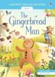 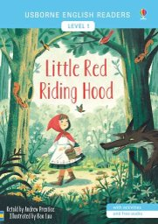 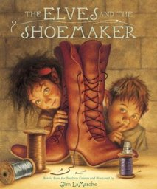 as well as many other traditional tales!
Please ensure your child reads every day. Please update their reading records.
Many thanks for your continued support, FS team

