FS Unit 2 Identity & Community

Main subject focus: Understanding of the World
Our topic enquiry question is: ‘Where do I live?’ ‘How has it changed?’’
The children will be learning to:
*Compare villages, towns and cities
*Understand where Earth is in our solar system
*Understand day and night, light and dark, shadows.
*Understand the changing seasons.

PSED:  Identity and diversity  The children will hear lots of stories about different communities. They will understand that we are all human but may look and sound different. We will talk about how we should treat everyone with respect.  Our ‘All about me’ sheets are now in a big book for the children to share with their friends. | Communication & Language  This term the children will have the opportunity to talk about their learning. Today I found literacy easy/hard because…..  I need help with…because…  We will also look at retelling stories using full sentences whilst expanding our vocabulary. | Physical Development  This term we will be working on gymnastics. We will use the apparatus and our bodies to move from high to low and under and over.  During outdoor sessions we will focus on ball skills.  PE days are Wednesday & Friday  Please leave PE kit in school so the children can change themselves.
Literacy  Our main focus this term will be ‘Here we are’ by Oliver Jefffers. This fabulous story was written for the author’s son to explain our planet and the animals and people who live here. The illustrations are fantastic and really get the children talking. | Phonics  The children have been learning their initial sounds and we will continue to build on this. We will focus on blending cvc words (consonant, vowel, consonant) such as man, cat, vet.  We will continue to practise tricky words that you can’t sound out such as the word ‘the’. | Maths  This term we will continue to focus on numbers to 5. We will look at simple addition and subtraction calculations. The children will continue to use manipulatives, part/part whole models and 5 frames. We will also introduce length and recap 2D shapes taught so far.
Music  This term we will focus on pulse and voice as we start to practise for this year’s nativity play. The children will also have opportunities to use some of our musical instruments. | Expressive Arts & Design  This term we will focus on printing. Starting with coin and leaf rubbing through to stencilling and roll printing.  We will learn about Paul Klees and his use of shape and colour.  We will also look at how to make flaps and hinges for design and technology. | E-Safety  Online relationships  The children will consider how to use technology safely. This covers what do to if a pop-up box appears, who to talk to if we are worried and asking permission to use devices.
RE  Children will continue to talk about the people and places that are special to them. We talk about family celebrations and this leads on to looking at religious celebrations.  The children will hear the nativity story and begin rehearsals for this year’s play. | Understanding our World  Through stories, we shall explore our planet.  We begin to understand that our planet is made up of land and sea.  We talk about the people and animals who live on Earth, noting similarities and differences.  We explore day and night, light and dark as we continue to look at the changing seasons. | Dates for the diary  Nativity – 12th and 13th December (approx 9am) More details to follow.  Last day of term 22nd December
Our class books will be:

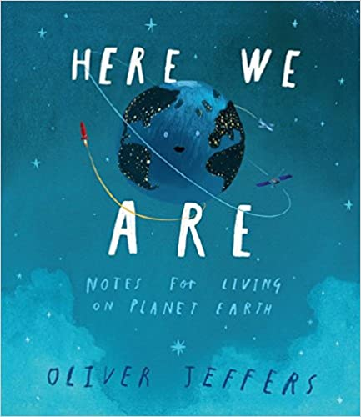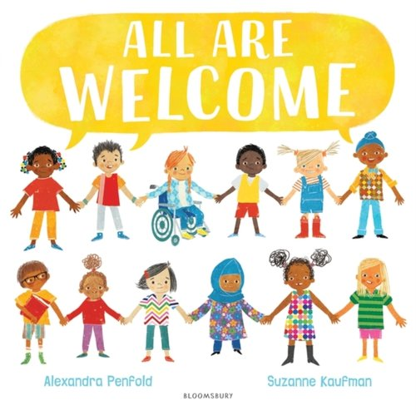

Reading book reminder
Please keep reading books at home to embed learning. Reading record books will be sent home shortly.

