Key Science Vocabulary
human | A person; human being. Humans are part of the group of mammals
body | The main part of a person or animal, not including the head, arms, and legs.
Baby | A very young child who needs to sleep and drink milk.
Toddler | A young child that is learning to walk and talk.
Adult | A person who is fully grown or developed.
features | A part of the face such as the eyes, nose, or chin.
senses | Any of five ways to understand or experience one's surroundings. The senses are touch, smell, taste, sight, and hearing.
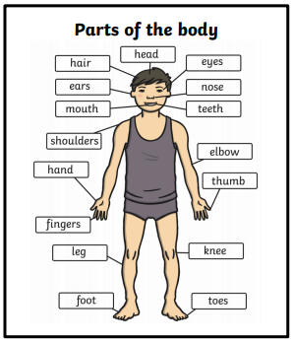
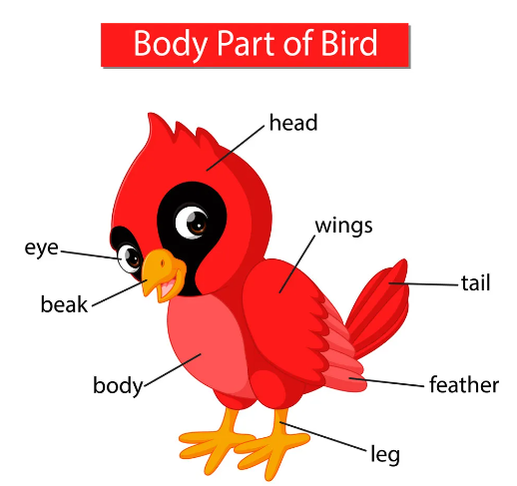
FS/Y1 Autumn 1
SCIENCE Knowledge Organiser

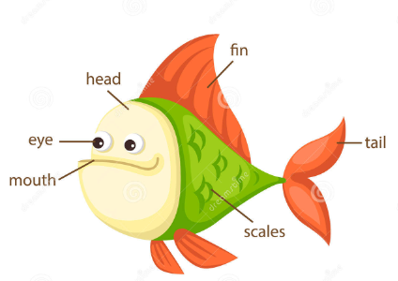
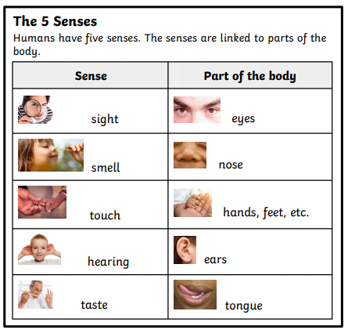

Mammals | Mammals include humans and all other animals that are vertebrates. They nearly all have hair and four legs. They have lungs and breathe air. They are warm blooded. Their babies are alive when they are born. Mammals need to look after their babies when they are born and baby mammals drink milk.
Birds | Birds are warm blooded vertebrates and they are the only animals with feathers. They all have two wings, two legs and one beak. They lay eggs and their young hatch out of them and need looking after when they are little. Birds have lungs and breathe air.
Reptiles | Reptiles are cold blooded vertebrates. They have dry skin covered with scales or bony plates. They either have four legs or no legs. When their young hatch out of their soft eggs they can look after themselves straight away.
Fish | Fish are vertebrates that live in water. They breathe under water using special organs called gills. Most fish lay soft eggs. They have scales over their bodies and fins that help them to swim.
Amphibians | Amphibians are cold blooded vertebrates that don’t have scales. They can live and breathe in water or on the land. Most amphibians lay soft eggs in water.

Carnivore | Eat meat, they eat other animals.
Herbivore | They eat plants.
Omnivore | They eat both animals and plants.
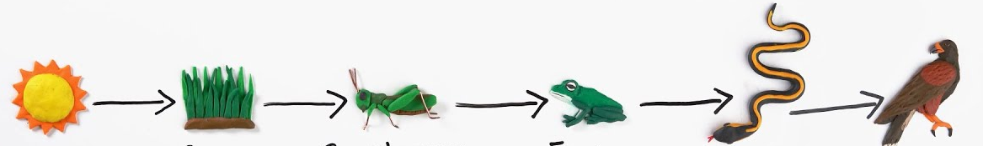

- Energy transfers between plants and animals when animals eat plants.
- Plants get energy from the sun.

