Year 6 Unit 1
English:  We will be writing an adventure story based on the book The Firework Maker’s Daughter by Philip Pullman. The children will learn how to build together a variety of sentence types to build an effective and cohesive piece of writing.  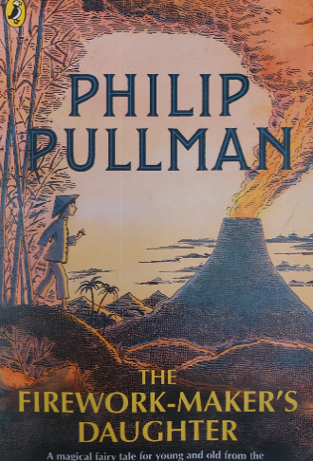 |  | Maths:  The children will be learning the following skills:  Place value –  identifying numbers up to 10,000,000  comparing, ordering and rounding integers  negative numbers  Addition and subtraction, multiplication and division –  Adding and subtracting numbers  Common factors, common multiples, square numbers, cube numbers, prime numbers,
Science  Enquiry question - What is light and shadow? How do we see things?  We will be investigating where light comes from and how it travels. We will also look at how our eyes interpret the images around us. |  | Geography  Enquiry question - Poles apart – where is the North and South Pole?  We will be looking at the features of the polar regions and comparing the Arctic with the Antarctic. We will study the effect of climate change and the impact of the polar caps melting.
PE  PE days: Tuesday & Friday  Tuesday:  Basketball - outdoor  Friday:  Gymnastics – indoor  Please ensure appropriate PE kit and footwear is brought in. Jewellery will need to be removed prior to the lesson and long hair will need to be tied up. | RE  Creation and science: Conflicting or complementary? |  | Spellings  Words with the following sounds: ay, e, ee, i, ie, o  Spelling list to learn: amateur, average, awkward, bargain, controversy, curiosity, develop, forty, guarantee
PHSE:
Blaby Stokes CE school values

Anti-bulling

Reading  Alongside our class novel, we will be using a range of texts to develop our reading skills of predicting, visualising, understanding vocabulary, summarising, and inferring. | ICT-  Communication  In this unit, the class will learn about the World Wide Web as a communication tool.  E-safety  Self-image and identity |  | Music  Pulse

Our class book is: The Middler by Kirsty Applebaum

We will be encouraging a love of reading ethos all year so we will have story time every day. Maggie’s never thought much about the Quiet War. It’s just somewhere the eldest kids get sent when they turn fourteen, like her big brother, Jed. But when she meets Una, a wanderer from outside the town boundary, she starts to see things differently. What if everything she’s ever been told is wrong?



