Year 2 Unit 1
Main subject focus: Geography

In Geography our enquiry question is: What is a capital city and why do they have big roads going to them, and special buildings in them?
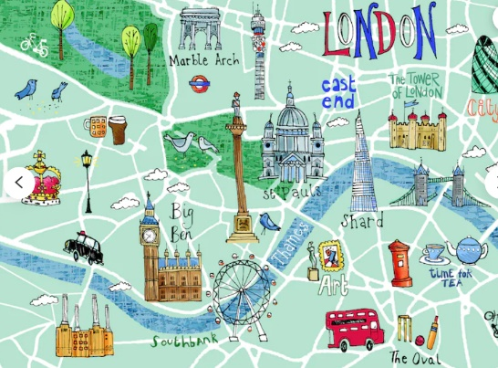
The children will investigate this question through the following 6 key questions:
- How can we make maps of our area?
- What is the United Kingdom?
- What are the capital cities in the United Kingdom?
- Why do we have capital cities and is there anything special about where they are located?
- Why is it important to be able to get to a capital city?
- Why do capital cities have castles or other important buildings in them?

English:  In our English lessons we will be learn how to write our own narrative story based on ‘The Building Boy’ by Ross Montgomery. |  | Maths:  In maths we will be learning about the place value of numbers up to 100, focusing on identifying the number of tens and ones We will also be counting in 2, 5s, and 10s.
Science: Uses of everyday materials  A Squash and a squeeze  How can I manipulate materials to change them?  Which materials are natural and which are manmade? |  | Computing  Computer systems and networks: IT all around us.  E-safety Self image and identity  I can explain how other people may look and act differently online and offline  I can give examples of issues online that might make someone feel sad, worried, uncomfortable or frightened; I can give examples of how they might get help.
PE  Indoor: Gymnastics  Outdoor: Dodging  PE days: Monday & Wednesday afternoons | Design and Technology  Free standing structures |  | Phonics  Unit 27- Sound /ae/ more spellings  <ai ay ea a-e a ei ey eigh>  Unit 28- Sound /d/  <d dd ed >  Unit 29- Sound /ee/  <e ee ea y ey ie I >
Music  Pulse | RE  Who is a Muslim and how do they live? (Part 1) |  | PHSE:  Anti-bullying

